**HOME AUTOMATION SYSTEM USING TINKERCAD**

This system attempts to automate basic home appliances in to order increase user’s safety and convenience.

It includes :

1. Automated fans
2. Lights
3. Gas monitoring
4. Automatic door

The sensors used are

* PIR sensor – automatic fan
* LDR(Photoresistor)-automatic light
* Gas sensor – alarm circuit is active when gas leaks
* Ultrasonic distance sensor- automatic door

**Components**

* Ultrasonic distance sensor
* Arduino uno R3
* Gas sensor
* Resistor
* Piezo
* Relay SPDT
* 5v Power supply
* Bulbs

Working

At daytime the bulb is automatically turned OFF



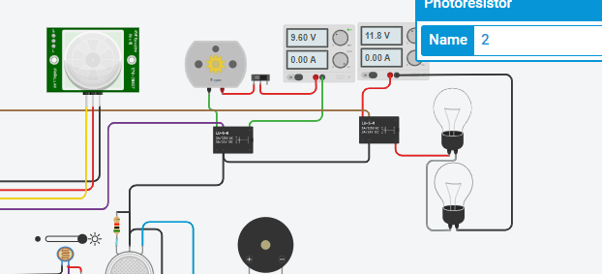



At night the bulb is automatically turned ON